File Input and Output

# Computer Files

* Types of Storage Device:
  + **Volatile storage** is temporary. Volatile values (stored in variables) are lost when the computer loses its power. The Random Access Memory (RAM) is being used when a Java program stores a value in a variable.
  + **Non-volatile storage** is permanent. A Java program that is saved on a disk uses a non-volatile storage.
* A **computer file** is a collection of data stored on a non-volatile device.
* Categories of File:
  + A **text file** consists of data that can be read in a text editor. Data in a text file is encoded using a scheme. The most common schemes are ASCII and Unicode. Examples are program files and application files.
  + A **binary file** contains data that is not encoded as text. This file has contents in binary format, which means they cannot be understood by viewing them in a text editor. Examples are images, music, and the .class extension files which are created after compiling Java programs.
* The common characteristics of a text file and binary file are size, name, and date and time of creation.
* Permanent files are commonly stored in the **main directory** or the **root directory**.
* To organize stored files, **folders** or **directories** are used.
* Users may also create folders within folders. The complete list of the disk drive plus the hierarchy of directories in which the file is located is called **path**.

Example of a complete path: **C:\Java\Chapter8\example.txt**

* In the Windows operating system, the backslash (\) is the **path delimiter** – the special character used to separate path components.

***The Path and Files Classes***

* The ***Path* class** creates objects that contain information about files and directories, such as sizes, locations, creation dates, and is used to check whether a file or directory exists.
* The ***Files* class** performs operations on files and directories, such as determining their attributes, creating input and output streams, and deleting them.
* To use both the *Path* and *Files* classes, add the following statement.

**import java.nio.file.*;**

* To create and define a *Path*, use the *Paths* class and its *get()* method.

# Example: Path filePath = Paths.get(“C:\\Java\\Chapter8\\sample.txt”);

* An **absolute path** is a complete path; it does not require any other information to locate a file on a system.

Example: **C:\Java\Chapter8\sample.txt**

* A **relative path** depends on other path information. Examples: **sample.txt**

# Chapter8\sample.txt Java\Chapter8

* *Path* Methods:

|  |  |
| --- | --- |
| **Method** | **Description** |
| String toString() | Returns the *String* representation of the *Path*, eliminating double backslashes |
| Path getFileName() | Returns the file or directory denoted by this *Path*; this is the last item  in the sequence of name elements. |
| int getNameCount() | Returns the number of name elements in the *Path* |
| Path getName(int) | Returns the name in the position of the *Path* specified by the integer parameter |

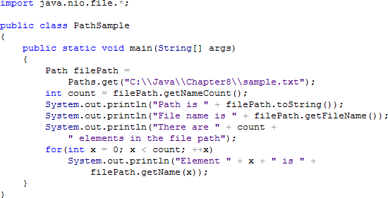Sample Program:

Output:

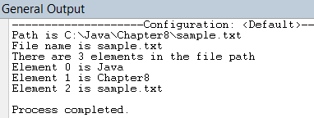

* 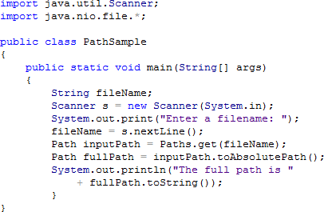To convert a relative path to an absolute path, the ***toAbsolutePath()*** method is used. Sample Program:

Output:

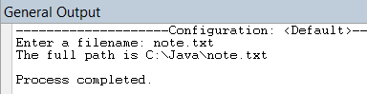

* To verify if a file exists and if a program can access it when needed, the ***checkAccess()*** method is used.
* Arguments of the *checkAccess()* Method:

|  |  |
| --- | --- |
| **Argument** | **Description** |
| None | Checks whether the file exists |
| READ | Checks whether the file exists and whether the program has permission to read the file |
| WRITE | Checks whether the file exists and whether the program has permission to write to the file |
| EXECUTE | Checks whether the file exists and whether the program has permission to execute the file |

* The ***delete()*** method of the *Files* class accepts a *Path* parameter and removes the last element (file or directory) in a path or throws an exception if the deletion is unsuccessful.
* Examples of Exceptions:
  + If there is an attempt to delete a file that does not exist, a ***NoSuchFileException*** is thrown.
  + If there is an attempt to delete a directory that has files, a ***DirectoryNotEmptyException*** is thrown.
  + If there is an attempt to delete a file without permission, a ***SecurityException*** is thrown.
  + Other input/output errors cause ***IOException***.
* The ***deleteIfExists()*** method can also be used to remove a file without encountering an exception if the file does not exist.
* To retrieve useful information about a file, the ***readAttributes()*** method of the *Files* class is used.

This method takes two (2) arguments.

These are *Path* object and *BasicFileAttributes.class*. The *readAttributes()* method returns an instance of the *BasicFileAttributes.class*.

Example:



* *BasicFileAttributes* Methods:

|  |  |
| --- | --- |
| **Method** | **Description** |
| size() | Returns the size of the file in bytes |
| creationTime() | Returns the date and time the file was created Format: yyyy-mm-ddThh:mm:ss  *(T stands for Time)* |
| lastModifiedTime() | Returns the date and time the file was last edited  *(Same format with creationTime())* |
| compareTo() | Compares relationship between values retrieved from  creationTime() or lastModifiedTime() |

# File Organization, Streams, and Buffers

* The smallest useful piece of data is the character. A **character** can be any letter, number, or other special symbol (such as punctuation mark) that makes up data.
* A **field** is a group of characters that has some meaning. Fields are grouped together to form records.
* A **record** is a collection of fields that contain data about an entity. Records are grouped to create files.
* A **file** consists of related records.

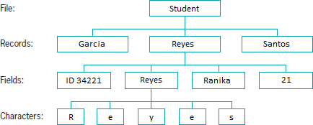

* When each record in a file is accessed one after another in the order in which it was stored, the data file is used as a **sequential access file**.
* A record’s fields can be organized into a single line or can be separated by a character.
* Values in a record that are separated by commas are called **comma-separated values**.
* A **stream** is a flow of data.
* If the data is taken from a source (such as a file or the keyboard) and is delivered into a program, it is called an **input stream**.
* If the data is delivered from a program to a destination (such as a file or the screen), it is called an **output stream**.
* A **buffer** is a memory location into which you can write data, which you can read again later.
* **Flushing** clears any bytes that have been sent to a buffer for output but have not yet been displayed on a hardware device.

# The IO Classes

* Input and Output Classes:

|  |  |
| --- | --- |
| **Class** | **Description** |
| InputStream | Abstract class that contains method for performing input |
| FileInputStream | Provides the capability to read disk from files |
| BufferedInputStream | Handles input from a system’s standard or default input device (usually the keyboard) |
| OutputStream | Abstract class that contains method for performing output |
| FileOutputStream | Provides the capability to write to disk files |
| BufferedOutputStream | Handles input from a system’s standard or default output device (usually the monitor) |
| PrintStream | Contains methods for performing output that never throws an  exception (System.out is a PrintStream object) |
| Reader | Abstract class for reading character streams; the only methods that a subclass must implement are read(char[] int, int) and close() |
| BufferedReader | Reads text from a character-input stream, buffering characters to  provide for efficient reading of characters, arrays, and lines |
| BufferedWriter | Writes text to a character-output stream, buffering characters to provide for the efficient writing of characters, arrays, and lines |

* Common Methods of the *OutputStream* Class:

|  |  |
| --- | --- |
| **OutputStream Method** | **Description** |
| void close() | Closes the output stream and releases any system resources associated with the stream |
| void flush() | Flushes the output stream; if any bytes are buffered, they will  be written |
| void write(byte[] b) | Writes all bytes to the output stream from the specified byte  array |
| void write(byte[] b, int off, int len) | Writes bytes to the output stream from the specified byte array  starting at offset position off for a length of len characters |

* The *Files* class’ ***newOutputStream()*** method is used to create a writeable file. A *Path* and a *StandardOpenOption* argument are passed to this method. This method creates a file if it hasn’t existed yet, opens the file for writing, and returns an *OutputStream* that can be used to write bytes to the file.
* *StandardOpenOption* Arguments:

|  |  |
| --- | --- |
| **StandardOpenOption** | **Description** |
| WRITE | Opens the file for writing |
| APPEND | Appends new data to the end of the file; use this option with WRITE  or CREATE |

|  |  |
| --- | --- |
| TRUNCATE_EXISTING | Truncates the existing file to 0 byte so the file contents are replaced; use this option with the WRITE option |
| CREATE_NEW | Creates a new file only if it hasn’t existed yet; it throws an exception  if the file already exists |
| CREATE | Opens the file if it exists or creates a new file if it hasn’t existed yet |
| DELETE_ON_CLOSE | Deletes the file when the stream is closed; it is used most often for temporary files that exist only for the duration of the program |

* The ***newInputStream()*** method of the *Files* class is used to open a file for reading. This method accepts a *Path* parameter and returns a stream that can read bytes from a file.
* A ***BufferedReader*** object is declared to read a line of text from a character-input stream, buffering characters so reading is more efficient.
* Common Methods of the *BufferedReader* Class:

|  |  |
| --- | --- |
| **BufferedReader Method** | **Description** |
| close() | Closes the stream and any resources associated with it |
| read() | Reads a single character |
| read(char[] buffer, int off, int len) | Reads characters into a portion of an array from position off for  len characters |
| readLine() | Reads a line of text |
| skip(long n) | Skips the specified number of characters |

# Sequential Data Files

* The ***BufferedWriter*** class writes text to an output stream, buffering the characters.
* *BufferedWriter* Methods:

|  |  |
| --- | --- |
| **BufferedWriter Method** | **Description** |
| close() | Closes the stream, flushing it first |
| flush() | Flushes the stream |
| newline() | Writes a line separator |
| write(String s, int  off, int len) | Writes a String from position off for length len |
| write(char[] array,  int off, int len) | Writes a character array from position off for length len |
| write(int c) | Writes a single character |